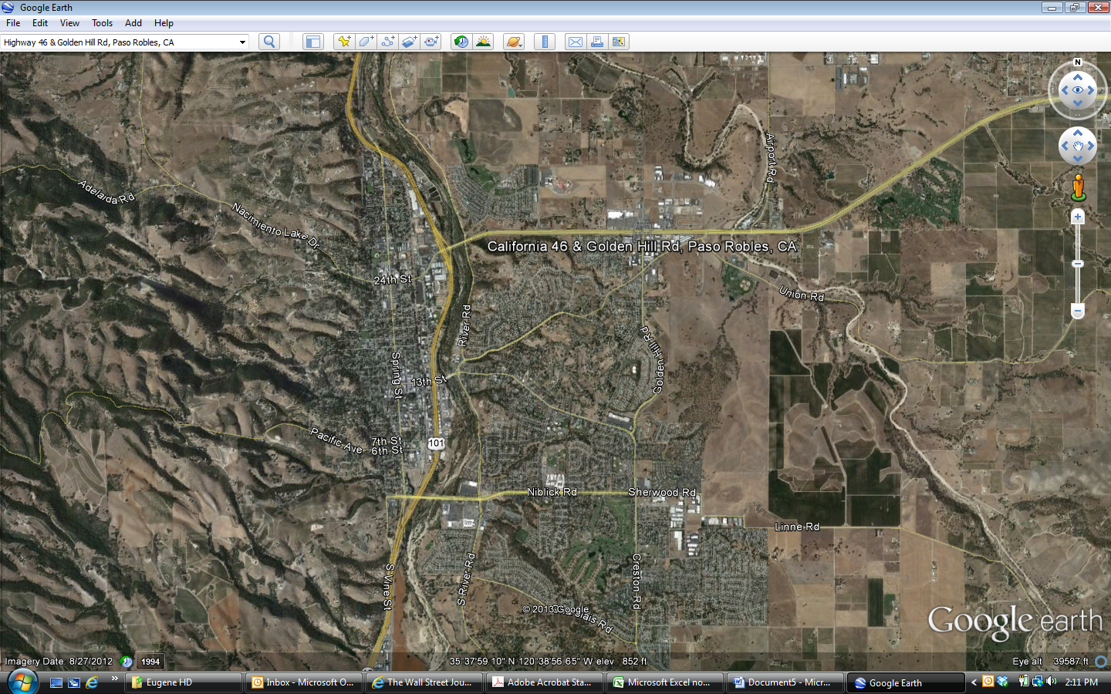

Wal-Mart

Big 5

CVS

Kohl’s

Downtown Paso Robles

Golden Hills Plaza